Lisa Stefanelli, (In)Delicate at The George Gallery, Laguna, Ca

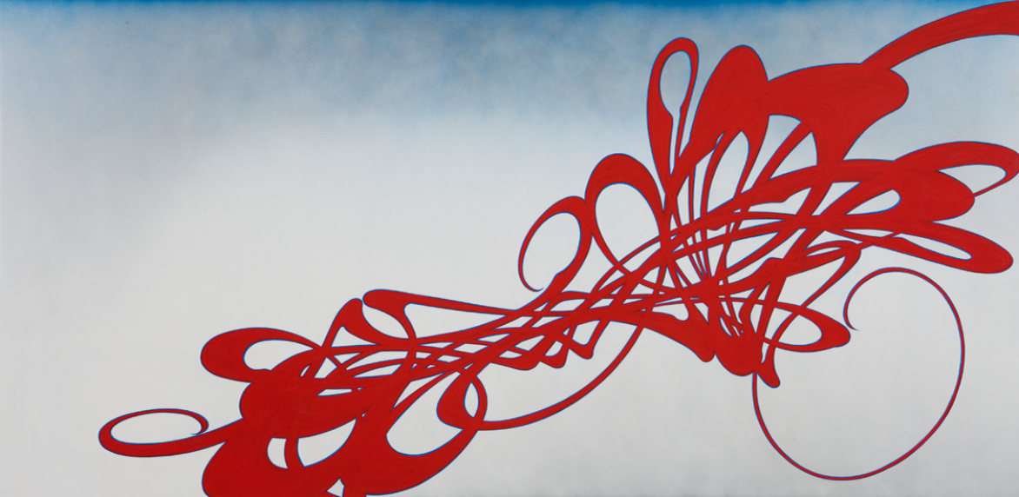

Stefanelli’s complex arabesques move between a delicate (musical) sense of beauty and a brawny physicality. Each work begins with a mark and a momentary plunder of the abyss—why paint when the world is already brimming with plentitude and wonder?—and each moment of nada is followed by Stefanelli’s full-on bodily engagement in the creation of new orchestrations of movement. Some movements play effortlessly toward resolution, while other entanglements suggest internal struggle, emotional torture and empty-eyed rapture.

In “(In)Delicate”, the artist walks a fine line between the delicate (elegant, nice, pretty and even beautiful) and the indelicate (aggressive, robust, bodily, indecorous and unapologetic).

Looking past her intricately imagined world, we see the world we live in…a place wherein the boundaries between the delicate and the indelicate aspects of femininity and female artistic expression are constantly being renegotiated. We know that nice girls finish last, but we also know that nice girls need not always be nice.

-AKN

